**DIY Mortar and Pestle Ram**

**TOOL LIST**

1 – 1” black pipe with an end cap

1 – smaller pipe that fits inside 1”, with an end cap

1 (or more) mesh screens

Crushing minerals and shell into small bits is sometimes required for smaller voids, filling divots, and air bubble repair. This can be done simply with a hammer or traditional mortar and pestle but typically the bits fly everywhere. Using a home-made pipe mortar and pestle ram gives you more control while containing and saving all of the crushed bits, even the fine powder.

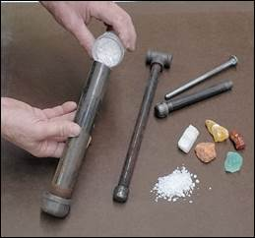 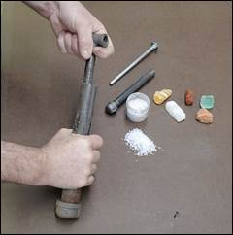  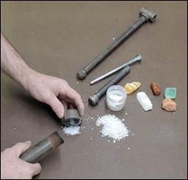

Use a 1” black pipe found at most hardware stores with an end cap for the mortar and (a small diameter black pipe with end cap or bolt that will fit inside the larger pipe for the ram (pestle). I have a large one for shell and minerals shown above and a smaller one for opal and finer minerals shown below.

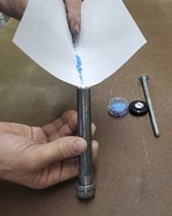 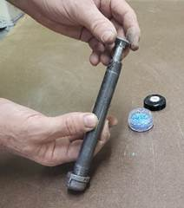  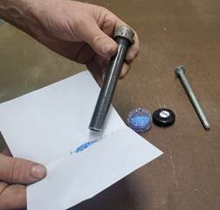

DIY Mortar and Pestle Ram

Page Two

The smaller one is a 3/8” pipe with end cap and a 5/16” x 8” carriage bolt with the threads cut off and tip rounded smooth. Both of these devices control the crushing of the minerals. Don’t overdo it and pound too hard, as this will pulverize the material into powder.

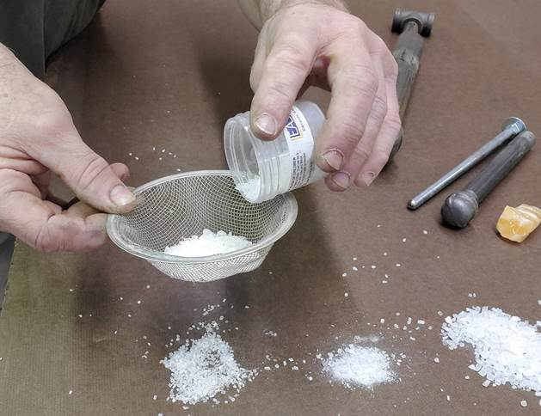

Crushed material can be purchased in various sizes, delineated by inches, mm, micron, or mesh screen, which can get quite confusing. Calibrated mesh screens can be quite expensive, and are a bit of overkill for our needs.  A simple method is to buy a kitchen sink drain screen. The one I have is about a 14 mesh / .05” and is perfect for sifting out finer bits. A flour sifter works well, too.

# # #